Customer: | Customer Today | Subject: | Subject Today
Customer Address: | Customer Address Today | From: | From Today
Customer Contact: | Customer Contact Today | Company: | Company Today
Inspection Site: | Inspection Site Today | Maverick Contact Info: | Cell Phone #: 1-800-2424-69  Email: emailtoday@gmail.com
Customer PO No.: | 2424-6969-420 | Maverick Job: | 20243425
Customer CCs: | Customer CCs Today | Maverick CCs: | P. Motta; MAS CTO
Inspection Date(s): | 10/01/2024 | Report Date: | 10/26/2024
Introduction: | Introduction Today
Entrance Meeting: | Entrance Meeting Today
Drawings provided and used during the inspection:
Drawing 1 Today
Drawing 2 Today
Drawing 3 Today
Drawing 4 Today
Specifications used during the inspection:
Specification 1 Today
Specification 2 Today
Specification 3 Today
Conclusions and Recommendations: | Conclusions and Recommendations Today

Description | Caption | Picture
Description 1 | General View of Chimney Liner | 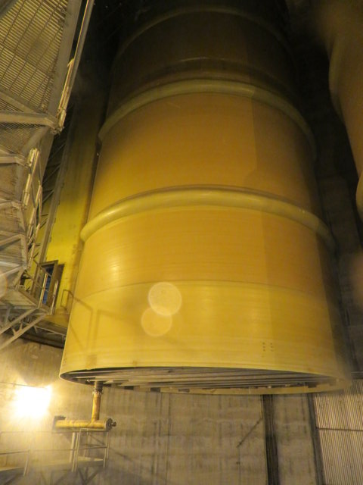
Description 2 | View of Floor Beam Attachment Bolts | 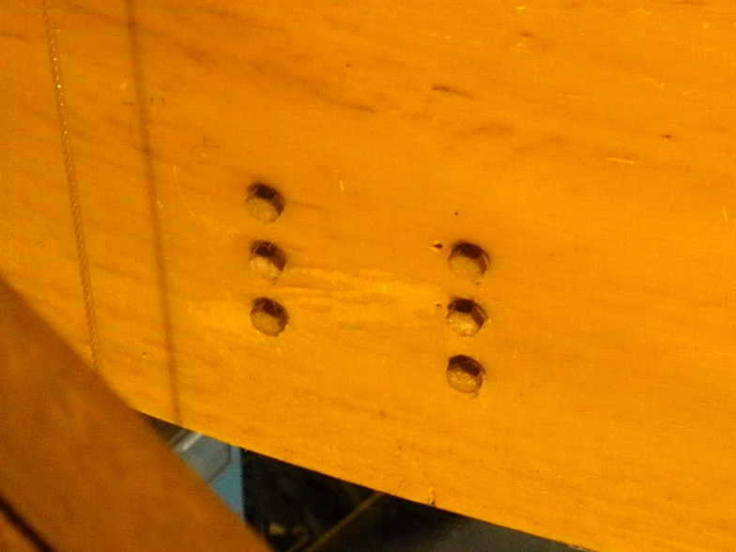
Description 3 | View of Chimney Liner Floor | 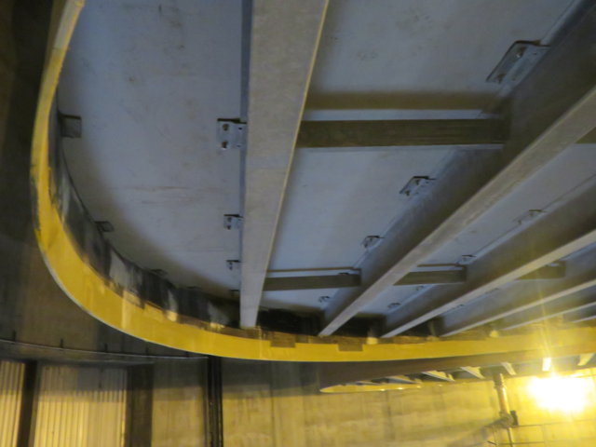
Description 4 | View of Chimney Liner Floor with Repair | 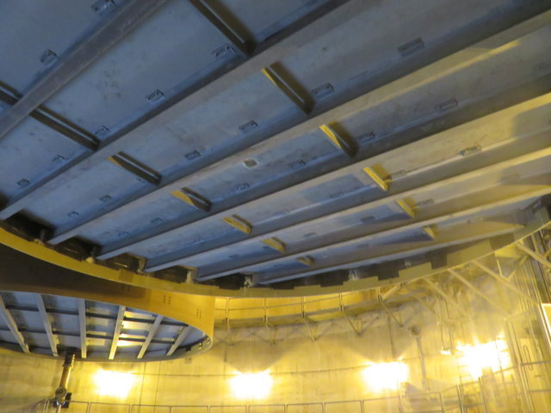
Description 5 | Up-close View of Chimney Liner Floor Repair | 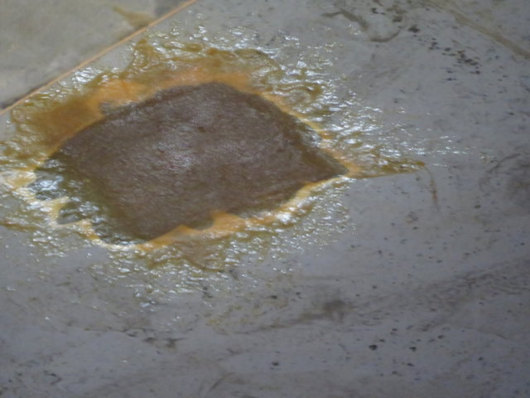
Description 6 | Close-up Internal View of Floor Repair | 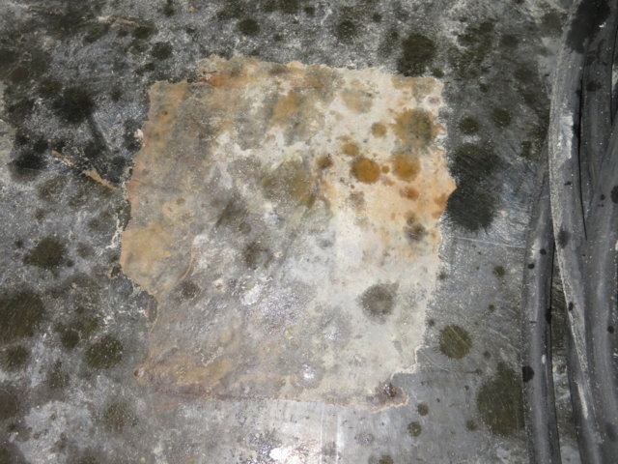
Description 7 | View of Breach to Shell Overlay | 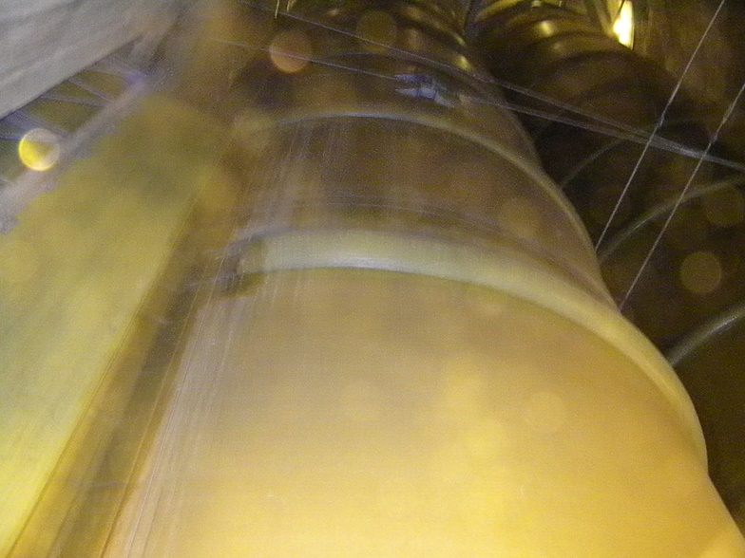
Description 8 | View of Breach to Shell Overlay | 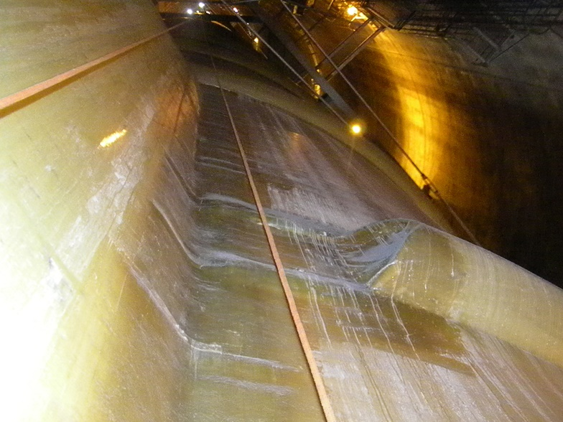
Description 9 | View of Entrapped Air in Breach to Shell Overlay | 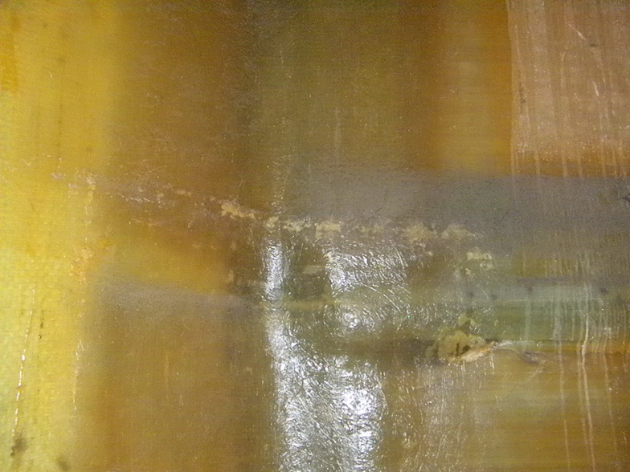
Description 10 | View of Contaminated Glass in Breach to Shell Overlay | 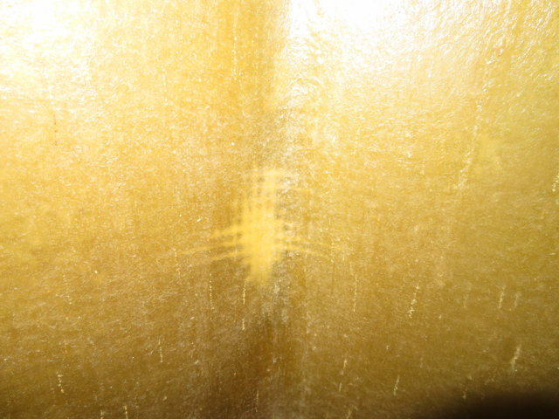
Description 11 | View of Contaminated Glass in Breach to Shell Overlay | 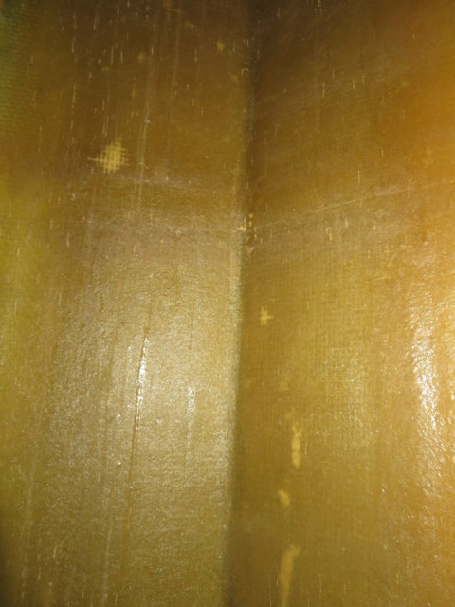
Description 12 | View of Contaminated Glass in Breach to Shell Overlay | 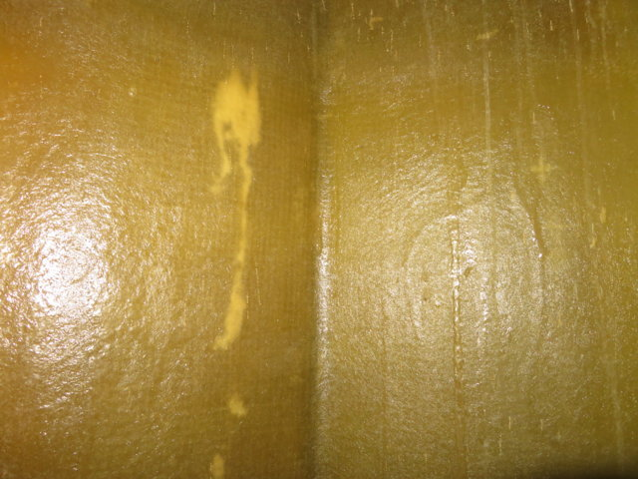
Description 13 | External View of Lower Corner | 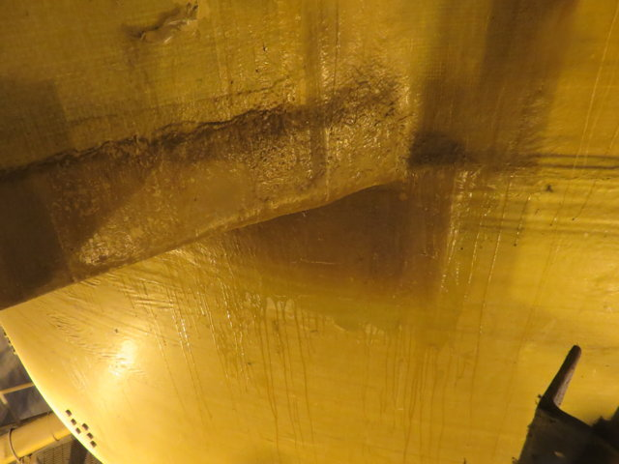
Description 14 | External View of Lower Corner | 

